**LAB-EXERCISE RIYA INDAP,44**

The file:

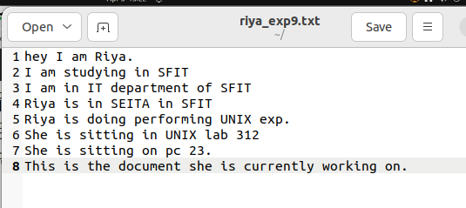

1.Write a grep script tp find the number of matched characters,words and lines in a file.

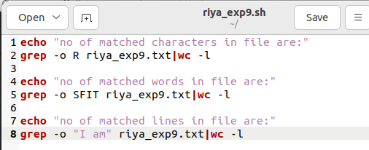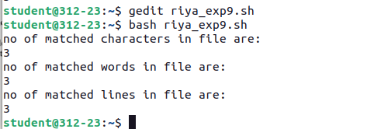

2.Write a grep script to find the number of characters,words and lines in a file.

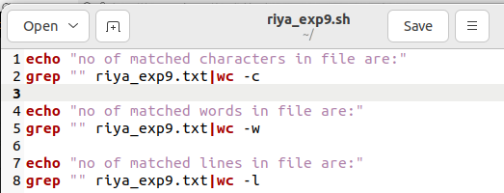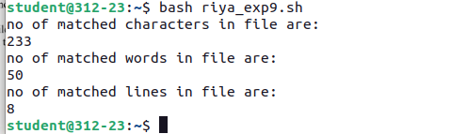

3.Write an egrep script to display list of files starting with a particular letter in the directory.

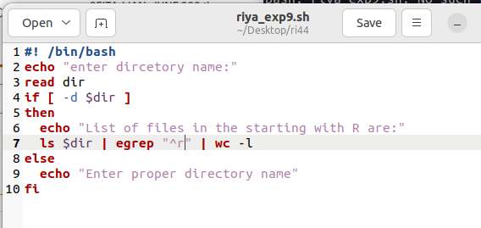

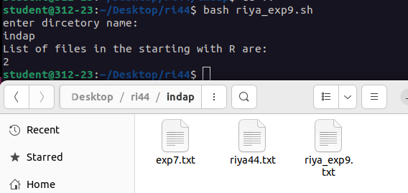

**POST-EXPERIMENT**

1.Write a shell program using grep to count number of files in a directory.

